``Title
Integration of Rapid Bioburden Testing into Production Quality Management Systems and Process Control

Authors
Irina Ramos^{1*+}, Michelle Najera²⁺, Gene Schaefer³
¹AstraZeneca irina.ramos@astrazeneca.com, Bioprocess Technologies & Engineering, Gaithersburg, Maryland, USA.
²Just-Evotec Biologics michelle.najera@evotec.com, Purification Process Design, Seattle, Washington, USA.
³National Institute for Innovation in Manufacturing Biopharmaceuticals (NIIMBL), gene@udel.edu Newark, Delaware, USA.
* Corresponding author
⁺ Irina Ramos and Michelle Najera contributed equally to this work.

ORCID:
Gene Schaefer 0000-0002-2937-8870
Irina Ramos 0000-0002-2759-1520

Abstract
The move to integrated continuous bioprocessing (ICB), while providing a means for process intensification, can put added strain on process analytics when conventional methods are used. For instance, traditional microbial methods provide minimal value to ICB processes given that the time required for data to become available is much longer than a typical full cycle of the manufacturing process. Although rapid microbial detection has been in discussion for over 30 years, it is still not routinely deployed in commercial biopharmaceutical manufacturing. One contributing factor is the ability to integrate this technology into a process control strategy and existing quality systems. An understanding of the capability of microbial detection technology available today can be leveraged to implement a control strategy for bioburden monitoring in real-time for process intermediates. One key tenet of this proposed control strategy is the use of a “two-tiered approach” wherein a fast (but possibly less sensitive) test is used to monitor the process and trigger further action for a second, longer duration test which is used to confirm and quantify the presence of bioburden and identify the organism. This approach, presented here alongside several case studies for microbial monitoring, can have broader application for other process analytical technologies where fit for purpose methods could be employed to establish process control alongside real time continuous processes.

Introduction
Intensified and continuous bioprocessing (ICB) is an effective strategy to accelerate manufacturing of biologics, with potential to increase productivity and reduce the cost of goods sold (COGs) [1] while requiring an increased ability to manage complex processes with automation and control [2,3,4], including a microbial control strategy (Figure 1). A key element of ICB is control of product quality and confirmation of a functionally closed system. The operational challenges include integrating equipment that will control a series of linked unit operations (upstream and downstream) at steady state for many days, keeping constant mass flow, having a synchronized automation strategy, and maintaining a closed or functionally closed end-to-end process.
Figure 2 compares continuous and batch processes, highlighting that continuous processing reduces or eliminates extended intermediate holds. This ultimately results in a significant shortening of the overall process times for continuous processes. Continuous operation thus limits access to non-routine or ad hoc samples for forensic testing and limits the time to respond to a deviation in product quality as well as investigate the potential root cause [5]. Numerous process options are possible for ICB as described in the N-mAb white paper [6]. To make this discussion more manageable and represent a worst case scenario in terms of response time, a fully continuous option for the ICB, will be considered in this publication.
Microbial control in an ICB process is a challenge due to sampling and time to result limitations noted above. Downstream process (DSP) bioburden control is typically performed on closed-systems with sanitized equipment or single-use components, with select components, e.g., filters, undergoing some form of pre-use sterilization. The detection component of a microbial control strategy historically relies on compendial methods [7,8] that require at least three days to get results and are based on a technology that is nearly 140 years old [9]. For the manufacturing of drug substance, compendial methods add value as a means to monitor microbial levels throughout the process, often with pre-defined in-process limits for each process intermediate. With a testing turnaround of three to five days, a positive result from a traditional bioburden test only identifies a contamination event in the past which may have become worse since the sampling event by migrating to other unit operations, process intermediates, or production lots. While this “run at risk” strategy is commonly used (where any out of specification levels are determined retrospectively for bioburden and product quality), rapid microbial testing allows an alternative faster microbial detection to determine process control. Especially in the case of bioburden, conventional testing returns results retrospectively, which is a waste of resources (raw materials or plant time) that are put into the process following an adverse microbial event and could present a risk to the re-use of certain materials such as chromatography resins if effective cleaning is uncertain. Furthermore, even batch processing with fast run rates requires rapid in-process bioburden testing if impact to multiple batches and subsequent steps is to be avoided.
Figure 3 illustrates in more detail the time frame of material as it moves from the bioreactor to the drug substance (DS) pool, 24 hours for a typical fully continuous process versus 96 hours for a batch process. This figure is a simplified example of how a single unit of material moves through the process based on the residence time in the absence of significant mixing or axial dispersion along the process flow. A full residence time distribution (RTD) would need to be performed for individual cases to understand the full effect of dispersion and mixing along the process [10,11]. Nonetheless, the diagrams in Figure 3 are informative in determining the approximate elapsed time, related to the residence time, between unit operation and batches for batch and continuous processing.
A timeline describing traditional bioburden testing is provided in Figure 4. Assuming daily samples, the bioburden detection does not occur until at least 72 hours on test have elapsed or 96 hours into the process, at which point material affected has already made it to the final step in the process according to the elapsed time described in Figure 4.. This demonstrates the limitations of current bioburden detection methods in protecting the product and manufacturing facility and the need for adapting new rapid technologies.

Need for Rapid Microbial Technologies
Obtaining information with respect to potential bioburden contamination days after material has been produced as drug substance is clearly not an effective way to monitor the process for control. A rapid bioburden testing strategy would bring a great benefit to the control strategy. This technology is not new; as far back as 1899, electrical conductivity in growth media was assessed as a way of measuring microbial growth [12]. Other rapid microbial testing and monitoring systems have been in development for over 30 years [13,14] but few, if any, are currently being used as part of in-process controls.
Advances in alternate methods for detecting and measuring microbial growth, often suitable for online monitoring, has been a great enabler to expedite the implementation of rapid microbial testing technologies across multiple fields [15]. In particular, the evolution since the 1950s of digital image processing (DIP), referring to converting an image into a digital signal and processing it by a computer, is an important element for microorganism detection and enumeration. For classical methods, the development of machine learning, deep learning, and other data analysis methods since 2015 has also progressed tremendously allowing more rapid analysis which is less subjective to human error [16].
Alternative or complementary technologies for microbial testing can be validated accordingly to commonly accepted standards such as USP <1223> [17], PDA TR33 [18] or Ph. Eur 5.1.6 [19]. However, it should be noted that the interpretation of these standards may depend on the nature of the test method [20]. Validation of in-process testing is typically under the control of an individual company’s quality management system (QMS) and governed by a Quality Risk Management (QRM) approach [21]. Risk assessment and risk management plans should be used to determine if a technology is appropriate and can accomplish the goal of quality by design. For many processes, bioburden monitoring of a process is not required to demonstrate assurance of sterility; rather, it should promote good quality product by demonstrating the bioburden control designed into the process. Furthermore, alternative testing that yields near real-time rapid results stands to be a far more effective tool for understanding and monitoring the process than a technology wherein detection lags far behind process execution. Accurate detection is more of a priority, but speed is essential to enable process control in real time. Finally, integrated automation can contribute to both expediting detection and removing human errors related to sample handling. Taken together, facilities of the future should look to microbial detection technologies that are fast, sufficiently accurate, able to integrate physically with the manufacturing process, and allow for streamlined automated data analysis. With these considerations in mind, a NIIMBL process intensification workstream team comprised of process engineers and microbiologists was formed to define a control strategy making use of rapid microbial testing. This team completed a user requirement specification list (Table 1) and compiled information about different technologies (Table 2).
Rapid methods and automation are dynamic areas in applied microbiology that promise improved methods for the isolation, early detection, identification and enumeration of microorganisms and their products. Colony forming units (CFU) refer to the number of individual colonies of any microorganism that grows on a plate of media. Traditionally, using a plate-based bioburden method, bioprocessing organizations have set action and alert limits based on CFU per mL of sample. Since newer technologies use different signals as a surrogate for the number of microorganisms, and some may be more qualitative than quantitative, implementation of these technologies will benefit from commonly accepted standards as noted earlier as well as more recent recommendations as to best practices [23].
The high sampling frequency described above for process control can be achieved in several ways: (1) using sample methods at high frequency, which may reduce the assay sensitivity [24] (2) multichannel technology, which enables processing of multiple samples in parallel; or (3) multiple instruments run in parallel, which is obviously more costly. For example, if the technology delivers sufficiently accurate results in 4 hours per sample, it can run up to 6 samples per day. With multichannel capability, it would deliver multiples of 6 samples per day.

Rapid Microbial testing as a PAT tool
The following text from the 2004 FDA guidance on process analytical technology (PAT) [25] is useful to consider within the context of rapid microbial technology: “Measurements collected from these process analyzers need not be absolute values of the attribute of interest. The ability to measure relative differences in materials before (e.g., within a lot, lot-to-lot, different suppliers) and during processing will provide useful information for process control. A flexible process may be designed to manage variability of the materials being processed. Such an approach can be established and justified when differences in quality attributes and other process information are used to control (e.g., feed-forward and/or feed-back) the process.” PAT applications include: real time estimation of product quality, which can be done as an alternative strategy to systematic end product testing, as part of the approach called real time release testing (RTRT) [26]; adjustment and control of unit operations at or before the sample point (feedback) or subsequent to sample point (feedforward) [27]; and fault detection, such as column integrity [28], which provides a reasonable level of assurance that the controlled state has been maintained. The focus of this paper is on the latter. The impact of process disturbances can be significant, especially for continuous processes lacking large volume hold tanks to accumulate material during a process pause [29]. Most PAT discussions and publications have focused on technologies, but it is important to consider the implications for decision making in real time. Here we use PAT for detection of faults in the microbial control strategy and to confirm the integrity of the closed system.
For the implementation of rapid microbial testing in bioprocessing, the concept of two levels or tiers of detection methods, analogous to PAT applications, are proposed here. The purpose of Test 1 is to assure process control, i.e., demonstration of containment and effective execution of aseptic practices in a time frame supporting the dynamic throughput requirements of continuous manufacturing and generating an in-process signal which should be investigated through the GMP Quality Management System. As such, the primary considerations are time and sufficient discrimination to allow effective quality management. The purpose of Test 2 is the resolution of investigations of special cause variation and can impact lot disposition. Because of this, Test 2 may take longer and require greater resources but should also provide greater discrimination and lower alpha and beta error.
Numerous barriers exist which limit the adoption of new technologies including immaturity of the technology or non-technical reasons such as corporate culture or practice [30]. However, even in the case of non-technical barriers, well documented examples or case studies demonstrating how a given technology can successfully be applied can be useful in lowering these barriers. Generating critical information faster is certainly necessary for making critical near real-time decisions during processing but it is not alone sufficient; that information must be linked to a well-defined decision tree which standardizes actions based on available test results.

Real-time control strategy using rapid microbial testing
By now, it is understood that rapid microbial technologies available today exhibit a range of capabilities with tradeoffs between speed and accuracy. To truly leverage faster detection times, a two-tiered assay approach is proposed here for deployment within manufacturing. The two-tiered approach is described in Table 3, where Test 1 and Test 2 are used together for different aspects of process control. Ideally, these assays could employ the same technology, but the test method would use different read times to achieve sufficient accuracy for the purpose of the test. Test 1 is run at a short duration and high frequency but would only be used as a monitoring tool to flag potential contaminations. Importantly, Test 1 is a fit for purpose assay that is an element of an integrated control strategy that monitors for signals, assesses their relevance, notifies the Quality unit if an investigation is appropriate, and may inform cautionary process stream segregation in the case of a positive signal. In this case, fit for purpose can be interpreted as analogous to what is proposed in the introduction of recent guidance on bioanalytical methods [31]. Test 2, meanwhile, is employed as a confirmatory test that can be used for lot disposition and to support QMS investigations. In other words, different risks are being managed by the two assays: Test 1 is suited for continuous in-process demonstration of the validated state and Test 2 is suited for managing risk to the patient.
The two-tiered control strategy for rapid Bioburden testing presented in Figure 5 is comprised of the following steps.
- Test 1 monitoring is performed at selected sample points.
- If a positive signal is measured with Test 1, e.g., greater than a pre-defined Action limit, then Test 2 is initiated for confirmation and identification of the contaminant. A QMS investigation is also opened.
- Concurrent with the immediate actions, a decision on how to handle the continuous process stream is required. A strategy of continuing processing with no manual intervention might be used, especially if the positive signal is an isolated event with a likely assignable root cause. Alternatively, a decision may be made for discretionary segregation of potentially contaminated material from uncontaminated process streams or downstream equipment.
- The result of Test 2 is used to resolve the QMS investigation for lot disposition.
  - If the result indicates no contamination, then segregated material can be recombined and normal processing can resume while an investigation into the positive result for Test 1 can be carried forth.
  - Alternatively, if Test 2 confirms the contamination, the process should be paused, or shutdown, and any contaminated material should be segregated if it has not been done already. Uncontaminated material may be assessed for forward processing and lot disposition. Following sanitization and remediation of the root cause such as a component swap, it may be possible return the train to service and resume monitoring with Test 1.

Sampling approach
A practical understanding of assay throughput should be used to inform an appropriate sampling approach for rapid microbial methods. For instance, sample points at critical unit operations with a higher risk of contamination should be prioritized if only one or two instruments with single channel processing capabilities are available. The goal of implementation of such methods would be to enable response to a contamination event within less than 48 hours by diverting contaminated process streams, swapping out contaminated equipment, or simply resolving a sampling error. Rapid microbial methods could also limit resource investment into an unrecoverable contamination event by early detection, allowing for expedient shutdown of the train, remediation of the root cause, and sanitization of affected processing equipment.
The elapsed time (or residence times) for each segment of the process should be well-characterized. An example of a rapid microbial sampling strategy, including elapsed time, is provided in Table 4. This sampling strategy also includes several intervention points intended to provide a means for process stream segregation in response to a process disturbance at a particular sampling point. Thus, the downstream intervention point(s) should be chosen based on an understanding of both the testing time required and the dynamics of the process flow. As examples, possible intervention points are also shown in Figure 6 between the bioreactor and the capture step and from the viral filter step to final formulation. Note that for rapid microbial in-process testing, it would be useful to identify not only an intervention point downstream of where the excursion was detected but an upstream intervention point would also be useful in preventing potential contamination of chromatography resins as described below in the second case study.

Process stream segregation
A key potential benefit of rapid bioburden testing is the ability to expediently detect, divert, and recover from a contamination event within a manufacturing run. However, the greatest challenge for successful implementation with a continuous process may be timely decision-making for where and when to divert and segregate material in response to a positive bioburden signal at a given point in the process, as described by ICH Q13 [32]. The strategy for these activities will depend upon the sample location that generated the positive bioburden signal, the testing duration, and the possible downstream process intervention points [6].
Concurrent with or following the confirmatory bioburden test with Test 2, a decision for how to segregate the process streams is required. A thoughtful material segregation plan relies predominantly on an understanding of material transport through the process according to flow rates, physical equipment, and corresponding residence time distributions. Residence times or RTDs for each segment of the process can be used additively to determine the extent of unit operations affected by a contamination and thus which process streams and equipment remain unaffected by the contamination [10,11].
One way to accomplish efficient decision making around bioburden contamination is to pre-emptively explore specific scenarios by considering test duration and frequency alongside residence times. Table 5 provides an example of test durations.

Case studies
Case studies for sample points 2 (Bioreactor), 3 and 4 (Permeate surge tank or post-capture surge tank), and 5 (TFF surge tank) were selected because these locations would stand to provide the greatest benefit from process intervention strategies that could be enabled if rapid microbial test data were employed. Several scenarios of increasing severity for these sample locations have been outlined below (Table 6, Table 7, and Table 8). In each case, a systematic approach should be taken following a positive signal from Test 1 or Test 2 according to the decision tree shown in Figure 5. The differences in the purpose of each of these tests (monitoring versus confirmatory) dictate the extent of the deviation management actions that are recommended. For this evaluation, the generic terms of Alert limit and Action limit have been used for severity.

Case Study 1: Bioreactor
A timeline describing implementation of this decision tree is provided in Figure 7. For rapid microbial testing, the contamination is detected at t=28 hour from the sample taken at 24 hour, and material related to the contamination has only been processed through the capture step. Therefore, in this case the rapid microbial testing would protect the remainder of the downstream train from contamination and allow faster return to service following the bioreactor shutdown and restart.

Case Study 2: Permeate surge tank or post-capture surge tank
The next case study evaluates a positive signal at the permeate surge tank or the post-capture surge tank (sample points 3 and 4 in Figure 6). These locations are considered together because the response to either would be similar. A timeline is provided in Figure 8 for the application of the control strategy in this scenario. For the simple case of the filter failure, rapid microbial technology could allow for detection, remediation, and resumed processing in less than 48 hours. This is in stark contrast to the evaluation discussed previously in Figure 4 using traditional bioburden testing at this process step where the material reaches the drug substance step before a test result is even available.
Although rapid microbial testing allows expedient detection and resolution following a contamination, handling material flows in real-time during a contamination event can still be challenging. Thus, it is also appropriate to discuss a segregation strategy for this process step, shown in Figure 9. Here, material flows versus elapsed time for each unit operation are superimposed with rapid microbial sampling events at the permeate surge tank. Decisions made with guidance from the control strategy are also superimposed in time on the chart. First, the positive result from Test 1 would trigger an immediate confirmatory measurement with Test 2. Again, using a basic residence time model for each unit operation (per Table 4), the movement of a single drop through the process is mapped out in process time. Figure 9 shows the drop of process fluid takes 8 hours to travel from the permeate surge tank to the capture step surge tank and 16 hours to travel through to the polishing steps to the VF surge tank. One strategic approach for this scenario would be to pre-emptively segregate at the post-capture surge tank following the positive result from Test 1 rather than wait for the Test 2 result at t=16 hours. Should the material be forward processed until the result is available from Test 2, then the appropriate intervention point to segregate contaminated material would be the UF/DF surge tank. For this case study, even though the result is not yet confirmed by Test 2, the earlier segregation strategy at the capture step is preferred because it better protects downstream equipment so that fewer steps require sanitization to resume normal processing if the contamination can easily be resolved.

One important note is that if a lower test frequency is used, the appropriate intervention points would likely move further downstream. Thus, there is a fine balance between excessive bioburden monitoring versus sufficient testing frequencies to mitigate the risk of microbial propagation further downstream in the continuous process.

Case Study 3: UF/DF tank
To lower the risk at this point of the process, a UF/DF dual tank operation allows for automatic segregation. A semi-batch operation wherein one vessel fills with virus-filtered product while the membrane assembly is on-line to the second vessel to perform UF/DF, product recovery, and periodic cleaning. When the TFF assembly is finished processing the fluid in the second vessel, it switches online to the first vessel to perform UF/DF while the second vessel begins filling with the virus-filtered product. Each tank is drained into a final drug substance bag before it gets filled again (Figure 10) [6]. In this case, the rapid microbial monitoring via Test 1 simply needs to be synchronized with the frequency of the UF/DF tank swap allowing for the testing time of 4 hours.

Conclusions
The time has come for microbial detection methods to align with the needs of modern processes such as integrated continuous bioprocessing. Especially when coupled with ICB, the status quo is simply ineffective at providing appropriate and timely feedback on the state of microbial control of the process. One key takeaway from this work for those wanting to implement rapid microbial techniques is that there is often a trade-off with current technologies between test duration and accuracy. In the approach presented here, short-duration rapid microbial testing is creatively employed as a monitoring tool to trigger subsequent and only as needed confirmatory testing. This strategy is designed with the current capability limitations of rapid microbial testing in mind along with risk-based considerations of meaningful sample points. Rapid microbial testing is an imperative technology for continuous manufacturing in order to mitigate the risk of bioburden as well as protect the purification train in the case of a bioburden event. Most importantly, alongside implementation of rapid microbial technology a strategic shift in the corresponding control strategy such as with the two-tiered approach offered here provides a comprehensive solution that offers manufacturers improved capabilities to meet the needs of their processes. Beyond the integration with the control strategy, challenges remaining with this technology include managing large amounts of data by leveraging predictive models and artificial intelligence (AI), sample volumes; and equipment integration and sterility (e.g. automatic sampling).

Acknowledgements

The authors gratefully acknowledge funding from award 70NANB21H086 from the U.S. Department of Commerce, National Institute of Standards and Technology. The authors also acknowledge extremely helpful input, insight, and comments from Jeffrey Baker, Ph.D. (NIIMBL), John Erickson, Ph.D. (NIIMBL), Allison Haug (NIIMBL), Jennifer Mantle, Ph.D. (NIIMBL), Joe Salazar (CRL), Jason Walther (Sanofi), and Lisa Wysocki (GSK) and Darren Cowley (AstraZeneca).

References

- Coffman, J., Brower, M., Connell‐Crowley, L., Deldari, S., Farid, S.S., Horowski, B., Patil, U., Pollard, D., Qadan, M., Rose, S., Schaefer, E., and Shultz, J. (2021) Biotechnology and Bioengineering 118 (4) 1735-1749. https://dx.doi.org/10.1002/bit.27690
- Farid, S. S. (2019). Integrated Continuous Biomanufacturing: Industrialization on the Horizon. 14(2), 1800722. https://dx.doi.org/10.1002/biot.201800722
- Konstantinov, K. B., & Cooney, C. L. (2015). White Paper on Continuous Bioprocessing. May 20–21, 2014 Continuous Manufacturing Symposium. Journal of Pharmaceutical Sciences, 104(3), 813-820. https://dx.doi.org/10.1002/jps.24268
- Warikoo, V., Godawat, R., Brower, K., Jain, S., Cummings, D., Simons, E., Johnson, T., Walther, J., Yu, M., Wright, B., McLarty, J., Karey, K.P., Hwang, C., Zhou, W., Riske, F. and Konstantinov, K. (2012). Integrated continuous production of recombinant therapeutic proteins. Biotechnology and Bioengineering, 109(12), 3018-3029. https://dx.doi.org/10.1002/bit.24584
- Grampp, G., Bosley, A., Qadan, M., Schiel, J., Spasoff, A., Valax, P., and Schaefer, G. (2023). Managing Integrated Continuous Bioprocesses in Real Time: Deviations in Product Quality. Accepted for Publication Biotechnology Progress
- NIIMBL. (2022). N-mAb: A case study to support development and adoption of integrated continuous bioprocesses for monoclonal antibodies Version 1. www.N-mab.org. Last accessed on November 14, 2023.
- Clontz, L. (2009). Microbial Limit and Bioburden Tests (Second ed.): CRC Press, Taylor & Francis Group.
- Grönberg, A., & Hjorth, R. A. (2018). Chapter 33 – Cleaning-in-Place and Sanitization. In G. Jagschies, E. Lindskog, K. Łącki, & P. Galliher (Eds.), Biopharmaceutical Processing (pp. 675-699).
- Pasteur, L. (1860) Expériences relatives aux générations dites spontanées, C.R. Acad. Sci., 50, pp. 303–307
- Lali, N., Jungbauer, A., & Satzer, P. (2022). Traceability of products and guide for batch definition in integrated continuous biomanufacturing. Journal of Chemical Technology & Biotechnology, 97(9), 2386-2392. https://dx.doi.org/10.1002/jctb.6953
- Sencar, J., Hammerschmidt, N., & Jungbauer, A. (2020). Modeling the Residence Time Distribution of Integrated Continuous Bioprocesses. Biotechnology Journal, 15(8), 2008. https://dx.doi.org/10.1002/biot.202000008
- Stewart, G.N. (1899) The changes produced by the growth of bacteria in the molecular concentration and electrical conductivity of culture media. Journal of Eperimental Medicine 4, 235-243.
- Fung, Daniel Y. C. Historical Development of Rapid Methods and Automation in Microbiology. Journal of Rapid Methods and Automation in Microbiology 1992 Vol. 1 Issue 1 Pages 1-14. https://dx.doi.org/10.1111/j.1745-4581.1992.tb00066.x
- Fung, Daniel Y. C. Comprehensive Reviews in Food Science and Food Safety 2002 Vol. 1 Issue 1 Pages 3-22. https://dx.doi.org/10.1111/j.1541-4337.2002.tb00003.x
- Zhang, X., Jiang, X., Hao, Z., & Qu, K. (2019). Advances in online methods for monitoring microbial growth. Biosensors and Bioelectronics, 126, 433-447. https://doi.org/10.1016/j.bios.2018.10.035
- Zhang, J., Li, C., Rahaman, M. M., Yao, Y., Ma, P., Zhang, J., Zhao, X., Jiang, T., and Grzegorzek, M. (2022). A comprehensive review of image analysis methods for microorganism counting: from classical image processing to deep learning approaches. Artificial Intelligence Review, 55(4), 2875-2944. https://dx.doi.org/10.1007/s10462-021-10082-4
- U.S. Pharmacopeial Convention (2019) General Chapter <1223> Validation of Alternative Microbiological Methods. In USP 42—NF 37, USP: Rockville, MD.
- Parenteral Drug Association Inc. (2013) Technical Report No. 33: Evaluation, Validation and Implementation of Alternative and Rapid Microbiological Methods; Bethesda, MD.
- Council of Europe (2008) Alternative Methods for the Control of Microbiological Quality, Chapter 5.1.6. In European Pharmacopoeia (Ph. Eur.), 6th Edition, Council of Europe: Strasbourg, France.
- Deutschmann, S., Paul, M., Claassen-Willemse, M., van den Berg, J., Ijzerman-Boon, P., Grunert da Fonseca, V., Brunbech, E., Johnson, L., Knutsen, C., Plourde, L., Salvas, J., Villari, P., Wysocki, L., and Franz-Riethdorf, M. (2023) Rapid Sterility Test Systems in the Pharmaceutical Industry: Applying a Structured Approach to their Evaluation, Validation and Global Implementation. PDA Journal of Pharmaceutical Science and Technology Jan 2023, pdajpst.2021.012672; https://dx.doi.org/10.5731/pdajpst.2021.012672
- ICH. ICH guideline Q9(R1) (2023) Quality Risk Management Guidance for Industry Retrieved from https://www.fda.gov/regulatory-information/search-fda-guidance-documents/q9r1-quality-risk-management Last accessed on November 14, 2023.
- Weber, R.E., Petkowski, J.J., Michaels, B. et al. Fluid-Screen as a real time dielectrophoretic method for universal microbial capture. Sci Rep 11, 22222 (2021). https://doi.org/10.1038/s41598-021-01600-z
- Ijzerman-Boon, P. C., Manju, M. A., & Van Den Heuvel, E. R. (2022). Non-inferiority testing for qualitative microbiological methods:Assessing and improving the approach in USP <1223>. Journal of Biopharmaceutical Statistics, 32(6), 915-941. https://dx.doi.org/10.1080/10543406.2022.2065498
- Friedman EM, Warner M, Shum SC, Adair F. (2015) In-process microbial testing: statistical properties of a rapid alternative to compendial enumeration methods. PDA J Pharm Sci Technol. 2015 Mar-Apr; 69(2):264-9. https://dx.doi.org/10.5731/pdajpst.2015.01019
- FDA. (2004). PAT-A Framework for Innovative Pharmaceutical Development Manufacturing and Quality Assurance. Retrieved from https://www.fda.gov/regulatory-information/search-fda-guidance-documents/pat-framework-innovative-pharmaceutical-development-manufacturing-and-quality-assurance Last accessed on November 14, 2023.
- EMA. (2012). Guideline on real time release testing. EMA/CHMP/QWP/811210/2009-Rev1. Retrieved from https://www.ema.europa.eu/en/documents/scientific-guideline/guideline-real-time-release-testing-formerly-guideline-parametric-release-revision-1_en.pdf
- Armstrong, A., Horry, K., Cui, T., Hulley, M., Turner, R., Farid, S. S., Goldrick, S., and Bracewell, D. G. (2021). Advanced control strategies for bioprocess chromatography: Challenges and opportunities for intensified processes and next generation products. Journal of Chromatography A, 1639, 461914. https://dx.doi.org/10.1016/j.chroma.2021.461914
- Rathore, A. S., Mittal, S., Lute, S., & Brorson, K. (2012). Chemometrics applications in biotechnology processes: Predicting column integrity and impurity clearance during reuse of chromatography resin. Biotechnology Progress, 28(5), 1308-1314. https://doi.org/10.1002/btpr.1610
- Satzer, P., Komuczki, D., Pappenreiter, M., Cataldo, A. L., Sissolak, B., & Jungbauer, A. (2021). Impact of failure rates, lot definitions and scheduling of upstream processes on the productivity of continuous integrated bioprocesses. Journal of Chemical Technology & Biotechnology. https://dx.doi.org/10.1002/jctb.6648
- Schaefer et al; Driving adoption of new technologies in biopharmaceutical manufacturing; Biotechnology and Bioengineering, 2023. http://doi.org/10.1002/bit.28395
- FDA. (2018). Bioanalytical Method Validation. Retrieved from: https://www.fda.gov/files/drugs/published/Bioanalytical-Method-Validation-Guidance-for-Industry.pdf Last accessed on November 14, 2023.
- ICH. (2023). ICH guideline Q13 Continuous Manufacturing of Drug Substances and Drug Products. Retrieved from: https://www.fda.gov/regulatory-information/search-fda-guidance-documents/q13-continuous-manufacturing-drug-substances-and-drug-products Last accessed on November 14, 2023.

Tables and Figures

.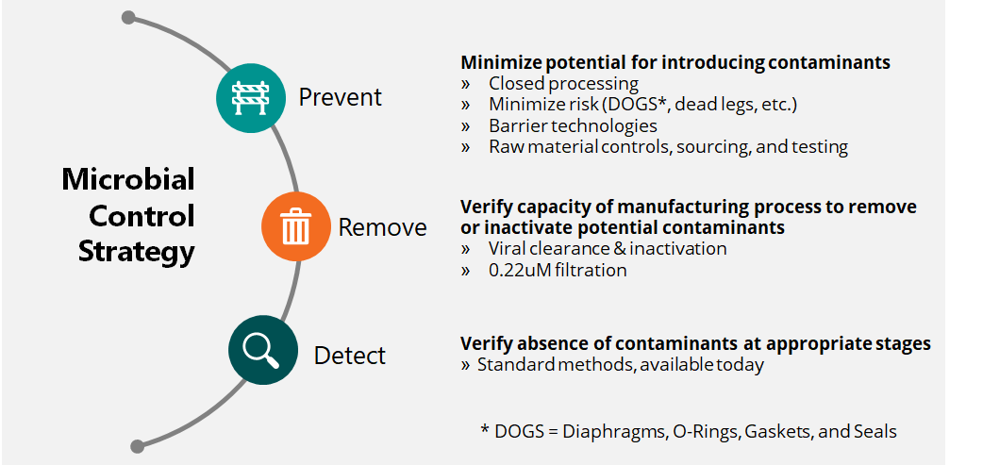
Figure 1 Microbial control strategy for bioprocesses

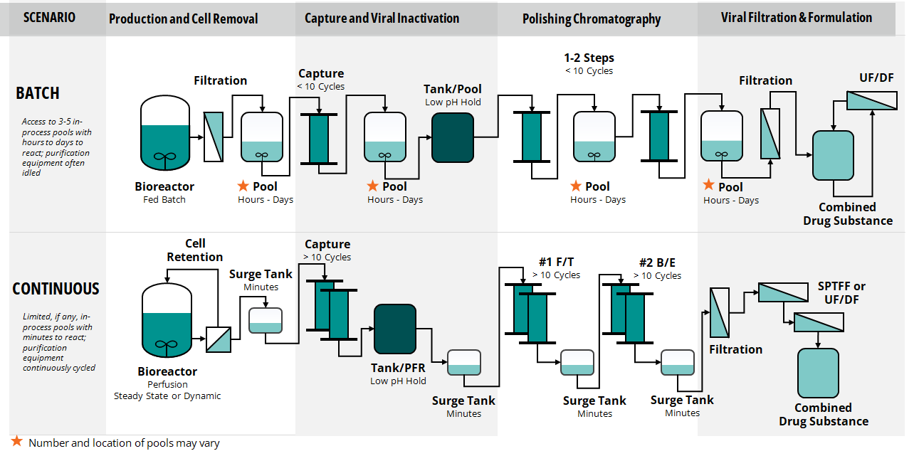
Figure 2 Challenges for Control in Continuous Processes: (a) batch operation and (b) continuous operation [6]

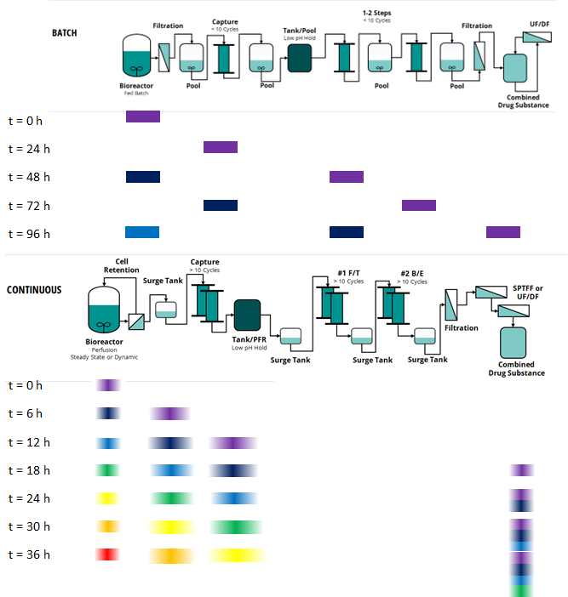
Figure 3 Flow Dynamics of (a) batch vs (b) continuous Processes [6]

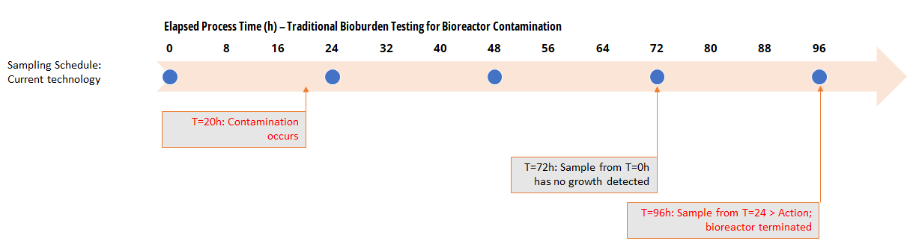
Figure 4 Timeline of contamination, detection, and remediation for traditional plate-based testing. Detection of a contamination event may take 72 hours or more.

Table 1 – User Requirement Specification for Rapid Bioburden testing
Category | Must Have Requirements | Nice to Have Requirements
Operation Mode | At line | Inline or online
Limit of Quantification (LOQ) | 10 CFU equivalents/mL | 1 CFU equivalents/mL
Microorganism detected | Common compendial indicating organisms  (Pseudomonas aeruginosa, Bacillus subtilis, Staphylococcus aureus, Candida albicans, Aspergillus brasiliensis) | Additional pharmaceutical isolates
Precision | no worse than ± 10CFU/mL | ± 1CFU equivalents/mL
Detection interference | Detection of viable microbes in representative process matrices: aqueous solutions (pH range of at least 4 to 8) containing common salts and buffers used for the purification of therapeutic large molecules.
Sample frequency | Up to 12 samples per 24hr  <4hr for single or 4-6hr for multichannel technology | <2hr for single or 2-4hr for multichannel technology
Sample size | ≤150 mL | ≤50 mL
Automation and Data collection systems | Integrates with common distributed process control and/or LIMS systems  (e.g., via OPC, ethernet I/O, device fieldbus, etc.)
Materials | Suitable for the manufacture of therapeutic proteins | Single-use and suitable for the manufacture of therapeutic proteins

Table 2 Rapid microbial testing technologies evaluated for near real time detection, by the NIIMBL PI control strategy team
Technology | Dielectroporesis + Microscopic Analysis | Traditional Cultivation with High-resolution 3D Optical scanning | ePetri Method for Imaging and Automated Detection | Solid-phase Cytometry | ATP Bioluminescence | PCR Technique
Detection basis | Visual  Novel bacterial dielectrophoresis (“microbe magnet”) coupled with high resolution fluorescence microscopy | Growth  Optical scanning detection of agar plated sample via high resolution microscopy. Uses traditional bioburden assay agar (TSA/SDA). | Visual / Growth  Optical scanning detection of agar plated sample via multi-angle illumination coupled with high resolution microscopy and image analysis | Metabolic  Solid Phase cytometry, esterase-sensitive fluorophore used to detect growing cells captured on a membrane via high resolution fluorescence microscopy | Filtration method combined with fluorescence technology | Patented hybrid PCR method with SwiftDetect
Equipment availability | Functional prototype | Commercially available | Prototype being developed | Commercially available | Commercially available | Commercially available for agriculture industry. Development on going for pharmaceutical industry
Time to initial detection¹ | <8hr | 4-10hr | Several minutes – few hours | 10 min – 12+ hr | 6-48hr | 6-8hr
Dependencies | Adherence of microbe with intact membrane to “microbe magnet”. | Visible organisms’ growth in agar matrix, Current version must be operated inside incubator. Self-incubating version in development | Microbe of sufficient size or colony formation | Viable organism. Different activation buffer and sample preparation times potentially needed for enumeration of different organisms or those injured/slow growing/spore-forming organisms | Membrane-based technology with possibility to rinse out any potential microbial growth inhibitory substances | Consistent method to extract DNA.  Availability of primers for icroorganism.
Organism detection | Compatibility with a wide range of organisms, including bacteria, yeast and molds. | Bacterial, yeasts and molds (longer time to detect). | Bacteria, yeasts and molds. Uses traditional bioburden assay agar (TSA/SDA) | Bacteria, yeast and molds, eukaryotic cells. Must be 0.3µm or larger to be detected. | Any microorganism with active metabolism – ATP bioluminescence detection based system | Pharmacopeia compendial organisms (aerobic bacteria, fungi), gram negative bacteria
Limit of Detection (LOD) | 1 cell/sample | 1 CFU/sample | 1 cell/sample | 10 CFU/sample | 1 CFU/mL | 1 CFU/mL
Vendor examples  (Technologies not limited to these companies) | Fluid Screen [22] | O’celloscope coupled to IntuGrow by IntuBio | Mango | Redberry Red One | Millipore Milliflex® Rapid System | Microgenetics
¹ Time of initial detection is based on vendor specs. It might depend on matrix interference and microorganism growth rate. Detection time for IntuBio was generated from a NIIMBL sponsored evaluation of this technology.
Table 3 Two-tiered assay approach for rapid bioburden testing
Tests | Purpose | Frequency | Assay Validation | Test Details | QMS Relevance
Test 1 | Monitoring | High | Fit for purpose: level of validation is appropriate for intended use | Shorter duration,  less sensitive | - Does not inform lot disposition  - Triggers Test 2 initiation  - May trigger segregation per QMS
Test 2 | Confirmation and ID of contamination | As needed | Validated | Longer duration, higher sensitivity | - Informs lot disposition

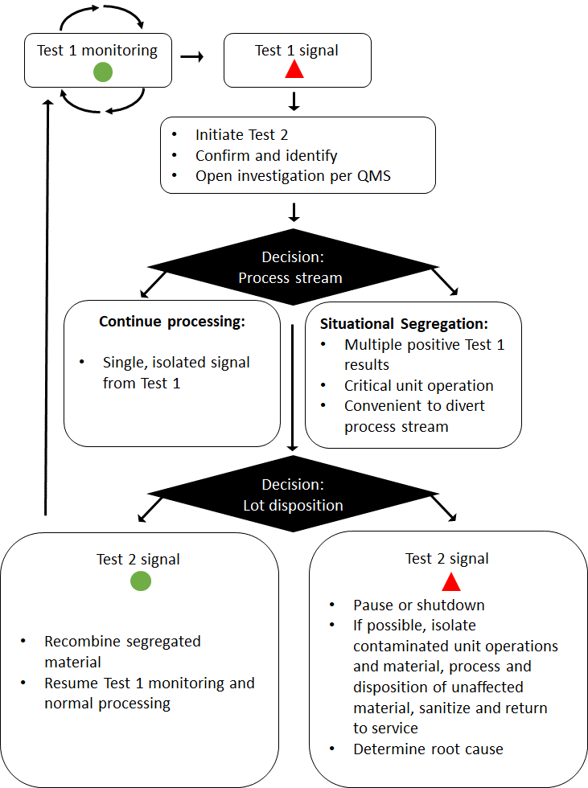
Figure 5 Decision tree for rapid microbial testing control strategy

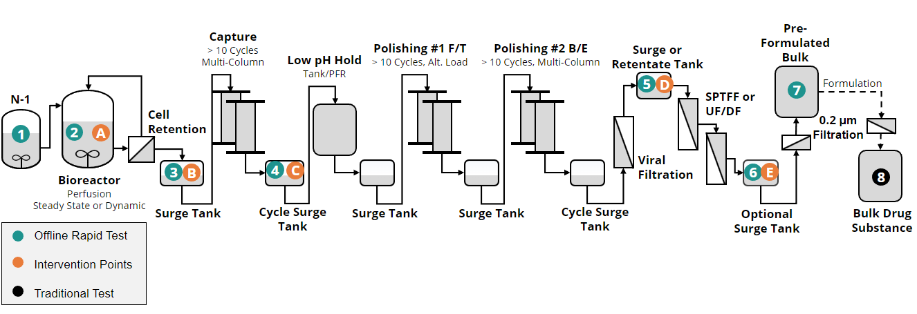
Figure 6 Rapid microbial sampling point prioritization for continuous bioprocess

Table 4 Rapid Bioburden sampling strategy, with sample and intervention points indicated in Figure 6.
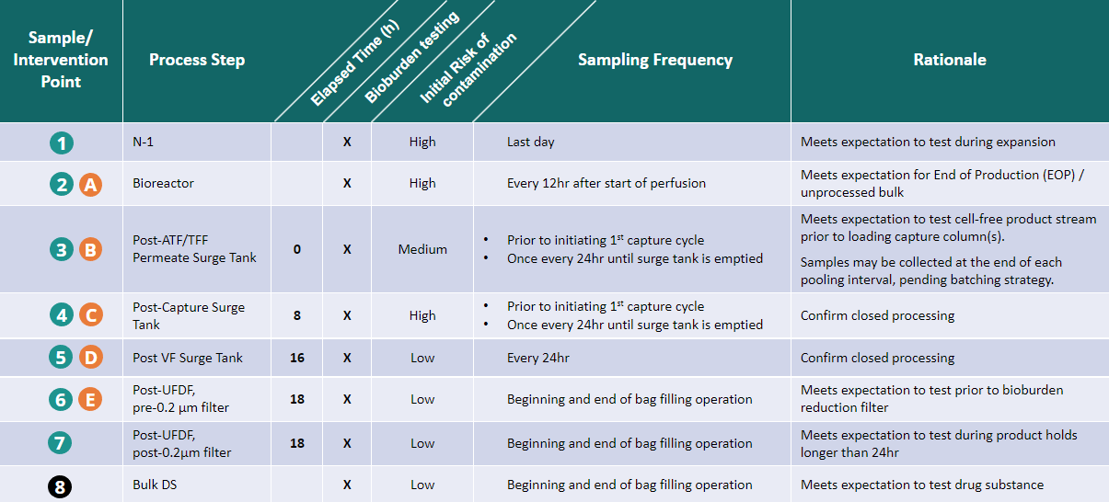

Table 5 Rapid microbial testing configuration for sample points
Details | Test 1 (Monitoring) | Test 2* (Confirmation)
Assay duration  (Includes sample preparation) | 4 hours | 12 hours
High frequency | Every 4 hours (requires unit operation dedicated instrument) | As needed per control strategy with option to increase frequency in response to positive signal
Low frequency | Every 8 hours | As needed per control strategy
* Test 2 can be the same methodology as test 1, where test 1 is an early readout of test 2.

Table 6 Scenarios for decisions with real-time bioburden monitoring: Bioreactor
Point of Detection | Severity | Causal Factor Assignable? | Root Cause | Deviation Management Considerations
Bioreactor  (sample point #2) | Test 1  > Alert limit | No | N/A | Immediate: Continue monitoring  Medium term: Investigate possible root causes
 | Test 1  > Action limit  or  multiple  > Alert limit | No | TBD | Immediate: Initiate Test 2  Medium term: Divert bioreactor effluent (segregate from material already processed). Investigate possible root causes; confirm sampling error & resume processing
 | Test 2  > Action limit | Yes | Faulty sample valve diaphragm | Immediate: Terminate bioreactor; divert any harvest material to waste  Medium term: Confirm root cause is solely responsible for contamination; replace diaphragm; restart bioreactor  Long term: Review CAPA related to maintenance schedule and operator training
 |  | No | TBD | Immediate: Terminate bioreactor; Initiate root cause investigation

Table 7 Scenarios for decisions with real-time bioburden monitoring: permeate surge tank or post-capture surge tank
Point of Detection | Severity | Causal Factor Assignable? | Root Cause | Deviation Management Considerations
Permeate surge tank  (sample point #3)  or  Capture eluate surge tank (sample point #4) | Test 1  > Alert limit | No | N/A | Immediate: Continue monitoring  Medium term: Investigate possible root causes
 | Test 1  multiple  > Alert limit  or  > Action limit | Yes | Biofilm in filter housing | Immediate: Initiate Test 2  Medium term: Pause forward processing of permeate surge tank; Investigate possible root causes  Long Term: Dissemble & clean filter housing, confirm with Test 1
 |  | No | TBD | Immediate: Initiate Test 2  Medium term: Pause forward processing of permeate surge tank; Investigate possible root causes; confirm sampling error & resume processing
 | Test 2  > Action limit | Yes | Leaking filter | Immediate: Pause all forward processing and segregate impacted material. Swap filters and sanitize system; resume operation  Long Term: Investigate root cause of filter leak and remediate as appropriate
 |  | No | TBD | Immediate: Pause all forward processing and segregate impacted material  Medium Term: Investigate root cause; remediate as appropriate

Table 8 Scenarios for decisions with real-time bioburden monitoring: UF/DF
Point of Detection | Severity | Causal Factor Assignable? | Root Cause | Deviation Management Considerations
UF/DF skid  (sample point #5) | Test 1  multiple  > Alert limit | No | TBD | Immediate: Initiate Test 2  Medium term: Pause forward processing of UF/DF; Investigate possible root causes
 | Test 2  > Action limit | Yes | Biofilm in UF/DF skid | Immediate: Pause forward processing of UF/DF; Dissemble & clean UF/DF skid, confirm with Test 1  Medium: Assess impact to previously process drug substance  Long Term: Investigate possible root causes
 |  | Yes | Leaking gasket | Immediate: Pause forward processing & segregate impacted material  Medium Term: Replace gasket and sanitize system; resume operation  Long Term: Investigate root cause of gasket leak and remediate as appropriate
 |  | No | TBD | Immediate: Pause forward processing & segregate impacted material  Medium Term: Investigate root cause; remediate as appropriate

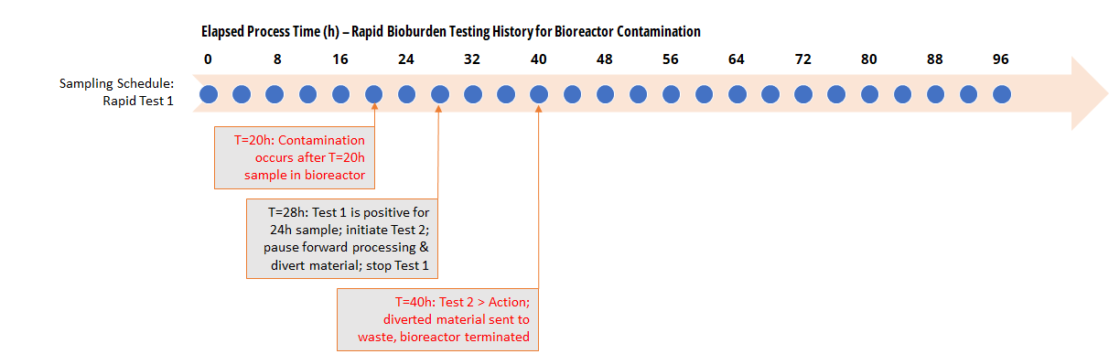
Figure 7. Timeline of sampling, contamination detection, and response in the bioreactor (Sample Point #2)

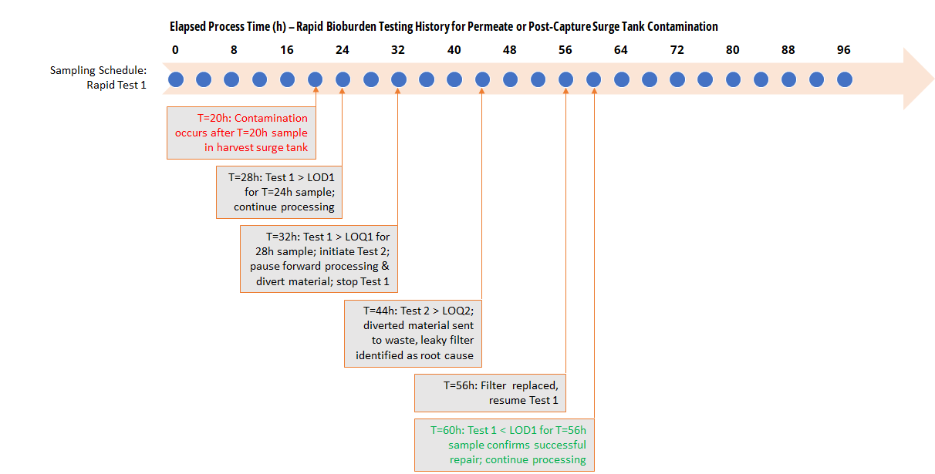
Figure 8. Timeline of sampling, contamination detection, and response for contamination in Permeate or Post-Capture Surge Tank

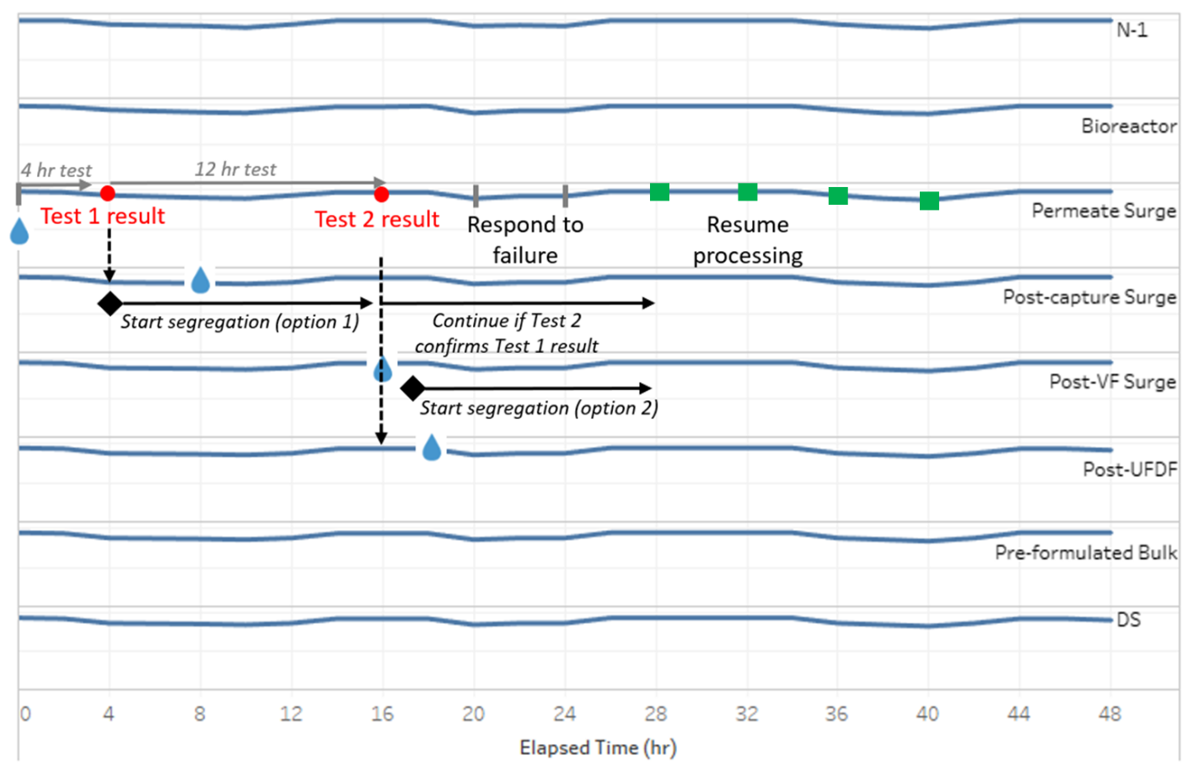
Figure 9. Segregation strategy for positive signal at permeate surge tank
The blue lines represent normalized protein concentration over time at each unit operation. The blue drops represent a given small aliquot of material as it moves down the process. The red circles and green squares along the permeate surge line represent samples taken and the color reflects the test result: red is > Action Limit and green is < Alert Limit
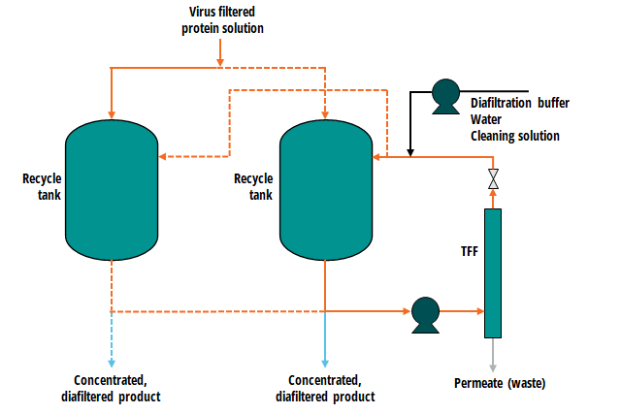
Figure 10. Continuous UF/DF using a cycling system, using one TFF system connected to two recycle vessels [6].

